Singular (1 person, place, or thing) Plural (more than person, place, or thing)



I = Yo We = Nosotros

____________________________________________________________________

You = Tú (familiar- someone you know well) You all = Vosotros
(you as a group of people --this form is
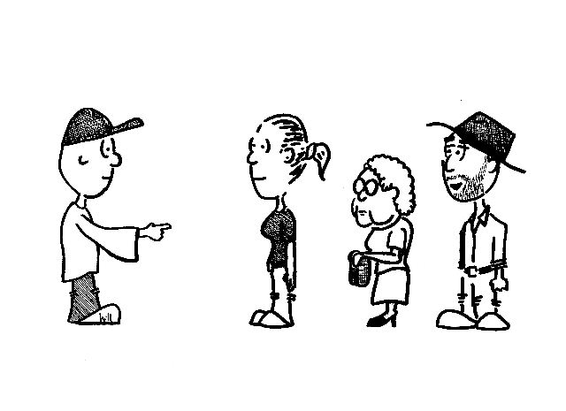

mainly used in Spain)

____________________________________________________________________
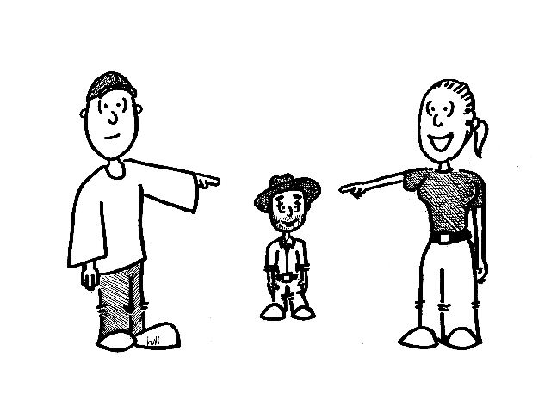

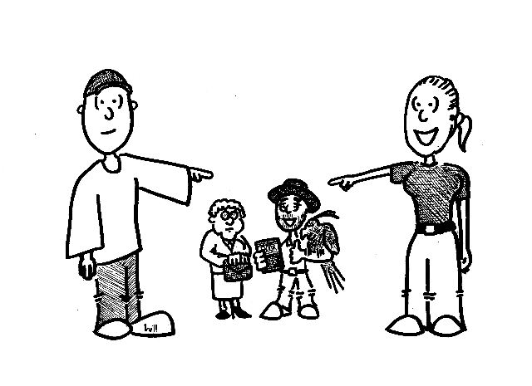
He = él They (girls) = ellas


She = ella They (boys) = ellos

Ud. = You (formal – someone older or that You guys = Uds. (use when you are
deserves respect; someone you do not addressing a group of people.
know well)

